Matlosana Fresh Produce Market was first established as “Klerksdorp Fresh Produce Market” in the City of Matlosana, North West Province on the 19th of January 1979 by the City Council of Klerksdorp and honorable H.Schoeman former Minister of Agriculture. Its main objective was to provide marketing facilities and administrative support to producers, market agents and buyers.
It started off with a floor space of 10 000m⁴ for selling purposes. At that stage there were no cooling or ripening facilities on the premises. Since then the market has grown to be the 8th biggest market amongst all the Fresh Produce Markets in the country, according to turnover in 2023.
In accordance with the change in town name, the Market was rebranded from "Klerksdorp Fresh Produce Market" to "Matlosana National Fresh Produce Market."

ROLES OF THE FRESH PRODUCE MARKET
- To manage and operate the fresh produce market facility in Matlosana
- To manage a commission-based business where producers deliver their products to their market agents who in turn then sell the produce to buyers.
- To generate income through a 5% non-negotiable commission for the municipality on the selling of all the fresh produce at the market.

VISION
To have an equally balanced supply and consumption of quality fruits and vegetables, encourage and promote appropriate initiatives with significant contribution to the local economy of the City of Matlosana and the North West Province.

MISSION
To create awareness across the North West Province, the neighboring provinces and countries, provide an efficient, effective and flexible trading platform within the Fresh Produce Industry and thereby becoming a trading platform of choice in South Africa- resulting in driven global competitiveness.

OBJECTIVES
· Create a fair-trading platform of quality fruits and vegetables.
· Contribute towards the economic development of its locality.
· Committed to offering the best service to the producers, buyers, agents and other stakeholders
· Encourage consumption of fruits and vegetables through relevant programs.
· Encourage and support SMME development (including emerging farmers).

We are here to serve you with fresh fruits and vegetables. Talks to us!!!
Market Agents Operating At Matlosana National Fresh Produce Market

People who receive fruits and vegetables from the farmers as well as
emerging farmers and sell them to the buyers are called Market
Agents.

 | Manager Contacts | Coenie Kruger  Cell No: 083 602 6428  Email : coenie@subtropico.co.za
 | Manager Contacts | Mariua Dreyer  Cell No: 083 287 0111  Email: admin@mmagents.co.za
 | Manager Contacts | Kobus Fourie  Cell No: 083 247 6412  Email: wlochse01@gmail.com
 | Manager Contacts | Heinrich Kock  Cell No: 083 306 0130  Email: heinrich.kock@rsa.co.za
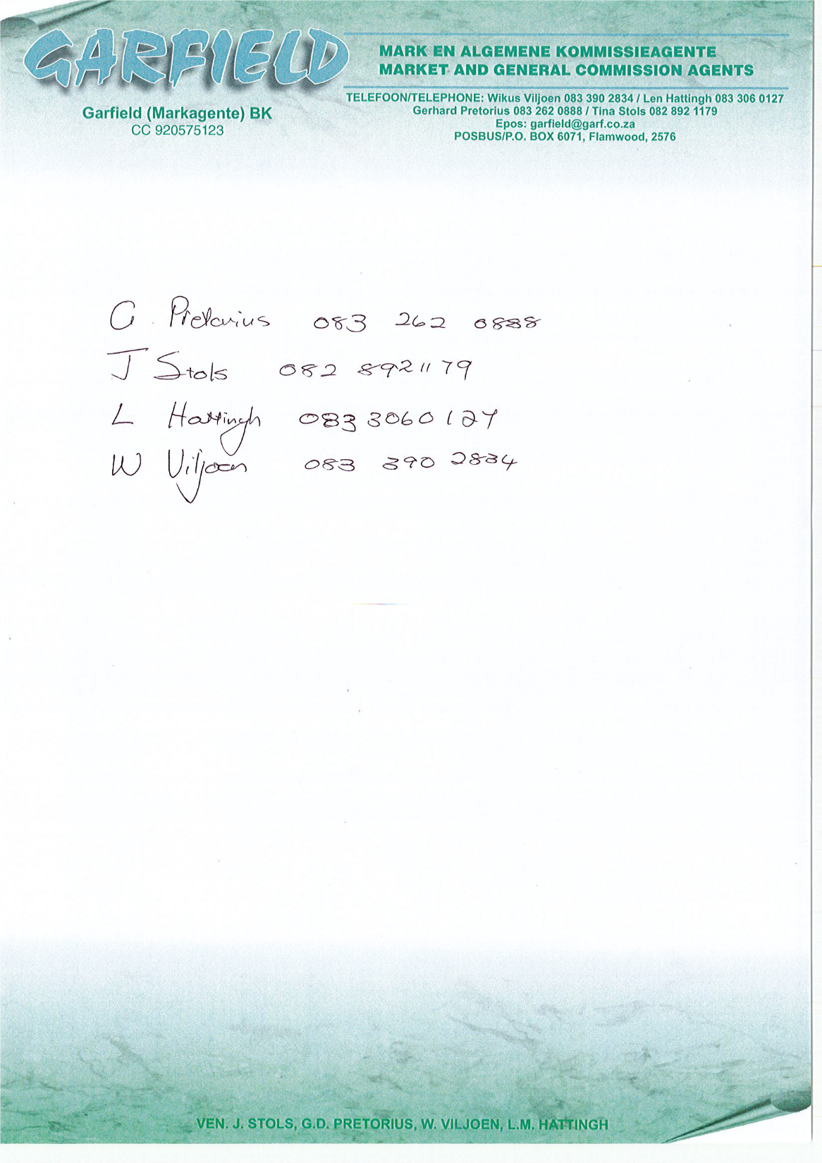 | Manager Contacts | Tina Stols  Cell No: 082 892 1179  Email: garfierld@garf.co.za

PRODUCT OFFERING
The market functions as a hub for the distribution of fruits and vegetables, which are sold by market agents acting on behalf of farmers, and then supplied to retailers and hawkers.

PRICING MODEL
Prices in the market are determined by various factors and therefore they fluctuate due to:
The forces of demand and supply.
Product availability
Product freshness and quality

DIVISION
· Finance and Administration
· Operation
· Marketing

MANAGEMENT CONTACT DETAILS

MARKET MASTER
Mr Mohau Victor Ramokanate
Tel : +27 18 487 8804
Fax : +27 18 469 3629
Cell : +27 84 255 2107
Email : mramokanate@klerksdorp.org

ASS MARKET MASTER ADMIN
& FINANCE
Mr Kgosietsile William Maponya

Tel: +27 18 487 8801
Fax: +27 18 464 1780
Phone: +27 78 981 3174
Email: wmaponya@klerksdorp.org

HOD Marketing
Ms Lorato Maphongo

Tel : +27 18 487 8802
Phone : +27 82 049 2866
Email : vmaphongo@klerksdorp.org

ACT ASS MARKET MASTER OPERATION
Mr Itumeleng Motingoe

Tel : +27 18 487 8803
Phone : +27 82 805 3906
Email : imotingoe@klerksdorp.org

BUYER’S CARD:
- There is a buyer's card that works like a bank card.
- Buyers card purchasing simply means that you deposit money into your own personal market account before purchasing produce.
- You need to apply for this special card before you can purchase.
- Use the buying card effective for that day only

HOW TO APPLY FOR A BUYERS CARD
- Collect a buyer's card application form at our customer services counter in our market sales hall.
- Complete the secure cash card application form.
- Hand in a complete form together with your I.D copy.
OR

You can deposit money into your account at any ABSA branch
Bank Name: ABSA
Account name: Klerksdorp Fresh Market
Branch code: 334338
Account No: 950000090

Deposit money into your buyers account Supply your buyers card with a number, which can be
found at the front of your card as a REFERENCE. You are ready to trade.

Requirements for Buyers
- Apply for secure cash card at the market office
- Complete the secure cash card application form
- Hand in a complete form together with your I.D copy
- Deposit money into your buyers account
- You are ready to trade
REQUIREMENTS FOR SUPPLIERS
According to Agricultural Standards Acts number 119 of 1190, all agricultural
products are required to be:
- Graded or classed according to standardized, objective, measurable minimum quality standards.
- Be marked or labelled accordingly.
- Be packed in a certain manner and container.
- Be named and farmers aggress should appear on the container
- Agents are required to enter an agreement with farmers to sell produce on their behalf.

